Ideation Phase
Define the Problem Statements

Date | 06 December 2025
Project Name | SkyWings - Flight Booking Application
Maximum Marks | 2 Marks

Customer Problem Statement – SkyWings:
To identify the core problems faced by online book shoppers and independent sellers while browsing, purchasing, and selling books online, and use these insights to guide the design and development of the Bookstore application. 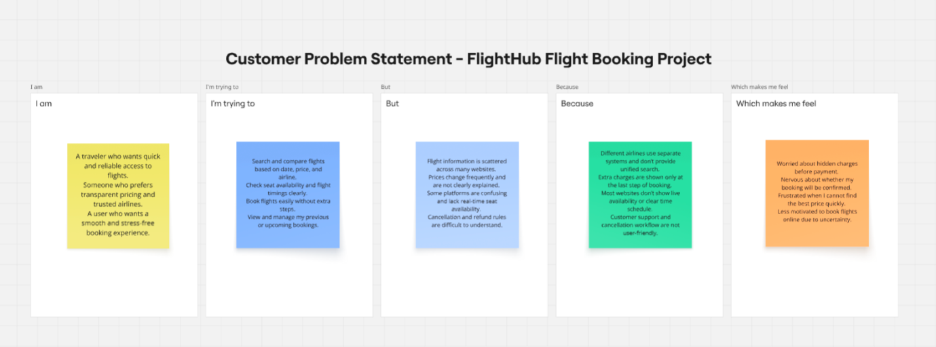

Problem Statement (PS) | I am (Customer) | I’m trying to | But | Because | Which makes me feel
PS-1 | A frequent traveler | search and book flights easily at an affordable price | flight information is scattered across multiple websites | there is no single platform showing all airlines with real‑time availability and price comparison | frustrated and tired of checking multiple sites before booking
PS-2 |  | compare flight prices and choose the best deals | many websites do not provide clear breakup of fare and hidden charge | taxes, cancellation charges, and additional costs appear only at final checkout | confused and anxious about the actual amount to pay.
  A price-conscious flyer
PS-3 |  | save flights for later and manage bookings quickly | some platforms don’t have wishlist or proper booking history | booking details and previous trips are not stored properly | disappointed and less motivated to continue using the platform
  A business traveler
PS-4 | A family/group traveler | book multiple seats together with preferred travel class | seat selection and class availability is inconsistent | the system does not show seat availability clearly during search | worried and unsure whether the whole family will get seats together
PS-5 | A travel admin | ensure flights are managed efficiently | manual management of flights and schedules takes time | there is no automated dashboard to add, update, or delete flights or view bookings | overwhelmed and stressed about delays and human errors
Passengers struggle to search, compare, and book flights confidently because prices, availability, and seat details are distributed across multiple platforms. The lack of transparency, real-time updates, and booking management features causes confusion, anxiety, and loss of trust. Flight administrators also face operational challenges due to the absence of a centralized dashboard for managing flight schedules and bookings — resulting in reduced efficiency and increased errors.

